

**PROJECT REPORT**

## On

E-commerce Website

Submitted in partial fulfilment of the requirement for the Course BEE (22CS026) of

**COMPUTER SCIENCE AND ENGINEERING**

**B.E. Batch-2022 in**

**Jan -2025**

|  |  |
| --- | --- |
| **Under the Guidance of :** - | **Submitted By:** - |
| Rahul Singh Rajput | Pratham Bajaj |
| Project Supervisor | Roll No.: 2210992072 |
|  | Pratham Choudhary |
|  | Roll No.: 2210992073 |
|  | Pratham Midha |
|  | Roll No.: 2210992076 |
|  | Prince Kumar |
|  | Roll No.: 2210992090  Nikhil Singla  Roll No.: 2210991982 |

**DEPARTMENT OF COMPUTER SCIENCE AND ENGINEERING**

**CHITKARA UNIVERSITY**

**PUNJAB**



# CERTIFICATE

This is to be certified that the project entitled “E-commerce Website” has been submitted for the Bachelor of Computer Science Engineering at Chitkara University, Punjab during the academic semester July 2024 – December 2024 is a bona fide piece of project work carried out by “Pratham(2210992072), Pratham(2210992073), Pratham(2210992076), Prince(2210992090) and Nikhil(2210991982)” towards the partial fulfilment for the award of the course Integrated Project (CS 203) under the guidance of “Rahul Singh Rajput” and supervision.

**Signature:**

Rahul Singh Rajput Project Supervisor (BE-CSE)



# CANDIDATE’S DECLARATION

We, Pratham(2210992072), Pratham(2210992073), Pratham(2210992076), Prince(2210992090) and Nikhil(2210991982), B.E.-2022 of the Chitkara University, Punjab hereby declare that the Integrated Project Report entitled “E-commerce Website” is an original work and data provided in the study is authentic to the best of our knowledge. This report has not been submitted to any other Institute for the award of any other course.

|  |  |  |  |
| --- | --- | --- | --- |
| **Signature:** | **Signature:** | **Signature:** | **Signature:** |
| Pratham Bajaj | Pratham Choudhary | Pratham Midha | Prince Kumar |
| 2210992072 | 2210992073 | 2210992076 | 2210992090 |

**Signature:**

Nikhil Singla

2210991982

Place:

Date:



# ACKNOWLEDGEMENT

It is our pleasure to be indebted to various people, who directly or indirectly contributed in the development of this work and who influenced my thinking, behaviour and acts during the course of study.

We express our sincere gratitude to all for providing me an opportunity to undergo Integrated Project as the part of the curriculum.

We are thankful to “Rahul Sir” for his support, cooperation, and motivation provided to us during the training for constant inspiration, presence and blessings.

Lastly, we would like to thank the almighty and our parents for their moral support and friends with whom we shared our day-to day experience and received lots of suggestions that improve our quality of work.

|  |  |  |  |
| --- | --- | --- | --- |
| **Pratham Bajaj** | **Pratham Choudhary** | **Pratham Midha** | **Prince kumar** |
| 2210992072  **Nikhil Singla**  2210991982 | 2210992073 | 2210992076 | 2210992090 |



# Table of Contents

|  |  |  |
| --- | --- | --- |
| **S. L. No.** | **Topics** | **Page No.** |
| 1 | Abstract | 6 |
| 2 | Introduction | 7 |
| 2.1 | Background | 7 |
| 2.2 | Problem Statement | 7 |
| 3 | Software and Hardware Requirement Specification | 8 |
| 3.1 | Methods | 8 |
| 3.2 | Programming/Working Environment | 8 |
| 3.3 | Requirements to Run the Application | 8 |
| 4 | Database Analysing, Design and Implementation | 9 |
| 5 | Program’s Structure Analysing and GUI Constructing | 9-12 |
| 6 | Code-Implementation and Database Connections | 13-14 |
| 7 | System Testing | 14 |
| 8 | Limitations | 15 |
| 9 | Conclusion | 15 |
| 10 | Future Scope | 16 |
| 11 | Bibliography/References | 16 |



1. **Abstract**

In the rapidly evolving digital marketplace, e-commerce has become a cornerstone of modern business operations. This project aims to develop a robust, scalable, and secure backend system for an e-commerce website, addressing the complex needs of online retail environments. The backend infrastructure plays a crucial role in ensuring smooth operations, scalability, and security for e-commerce platforms, ultimately enhancing the user experience and driving business growth. The project focuses on creating a comprehensive backend solution that encompasses key components essential for a successful e-commerce platform. These components include product management, user authentication and authorization, order processing, inventory management, payment integration, and data analytics. By leveraging modern technologies and best practices in software development, the system aims to provide a seamless and efficient experience for both customers and administrators.

Central to the project's design is a robust backend infrastructure that ensures scalability and reliability as user demand grows. Utilizing cloud-based solutions and microservices architecture, the website will handle high traffic volumes and large product catalogs without compromising on performance. The frontend will be developed with responsive design principles to ensure accessibility across all devices, from desktops to mobile phones. Additionally, the platform will include an intuitive content management system for vendors, allowing them to easily manage their inventory, track sales analytics, and engage with customers through targeted marketing campaigns. This dual focus on user experience and vendor empowerment positions the website as a versatile tool in the rapidly evolving e-commerce landscape.



# Introduction

## Background

A successful e-commerce project requires a focus on user experience, security, and scalability. Ensuring a seamless and personalized shopping experience is crucial for customer satisfaction and retention. This involves integrating advanced search functionalities, personalized recommendations, and secure payment gateways. Platforms have demonstrated the importance of a user-friendly interface and diverse payment options in building trust and convenience for customers.

Additionally, maintaining high security standards is essential to protect sensitive customer data and ensure compliance with regulations. The backend infrastructure of an e-commerce website must be robust enough to handle high traffic volumes and large datasets efficiently. This often involves leveraging cloud-based solutions and microservices architecture to ensure scalability and reliability. Advanced database management systems are also critical for efficient data handling and accessibility. Furthermore, adopting a headless commerce approach can provide greater flexibility for frontend innovations, allowing businesses to deliver personalized experiences across multiple channels without being constrained by traditional system limitations.

## Problem Statement

E-commerce websites have significantly transformed the shopping experience by addressing several key challenges faced by traditional retail models. One major problem solved by e-commerce is the limitation of geographical reach. Traditional brick-and-mortar stores are confined to serving customers within a specific location, whereas e-commerce platforms allow businesses to reach a global audience, breaking down geographical barriers and expanding their customer base.

E-commerce also addresses the challenge of operational costs. By eliminating the need for physical storefronts, businesses can reduce overhead expenses such as rent and utilities. These savings can be passed on to consumers in the form of lower prices and more frequent promotions, making online shopping more attractive.



# Software and Hardware Requirement Specification

## Methods

An e-commerce website is an online platform that facilitates the buying and selling of goods and services. It offers features such as product listings, secure payment processing, and customer support, enabling businesses to reach a global audience and providing consumers with a convenient, 24/7 shopping experience from any device.

## Programming/Working Environment

The development environment for E-commerce Website includes:

* + - ***Frontend:*** HTML, CSS, JavaScript, and React.js
    - ***Backend:*** Node.js with Express framework
    - ***Database:*** MongoDB for data storage
    - ***Cloud Services:*** AWS or Azure for hosting and storage
    - ***IDE:*** Visual Studio Code
    - ***Version Control:*** Git for source code management

## Requirements to Run the Application

### Hardware Requirements:

* + - * A computer or server with at least 8GB RAM and 4 CPU cores
      * Stable internet connection

### Software Requirements:

* + - * Node.js and npm installed
      * MongoDB database server
      * Web browser (latest version)



# Database Analysing, Design and Implementation

E-commerce website utilizes MongoDB for its database, which allows flexible storage of user ID, product list and prices. The database schema includes collections for users login details, choices and interest.

* User ID
* Access permissions

# Program’s Structure Analysing and GUI Constructing

The application is structured into several modules:

* ***User Authentication:*** Handles login and registration for patients and doctors.
* ***User Profile:*** Provides an overview of uploaded records and allows quick access to your details, orders, cart and payment settings.











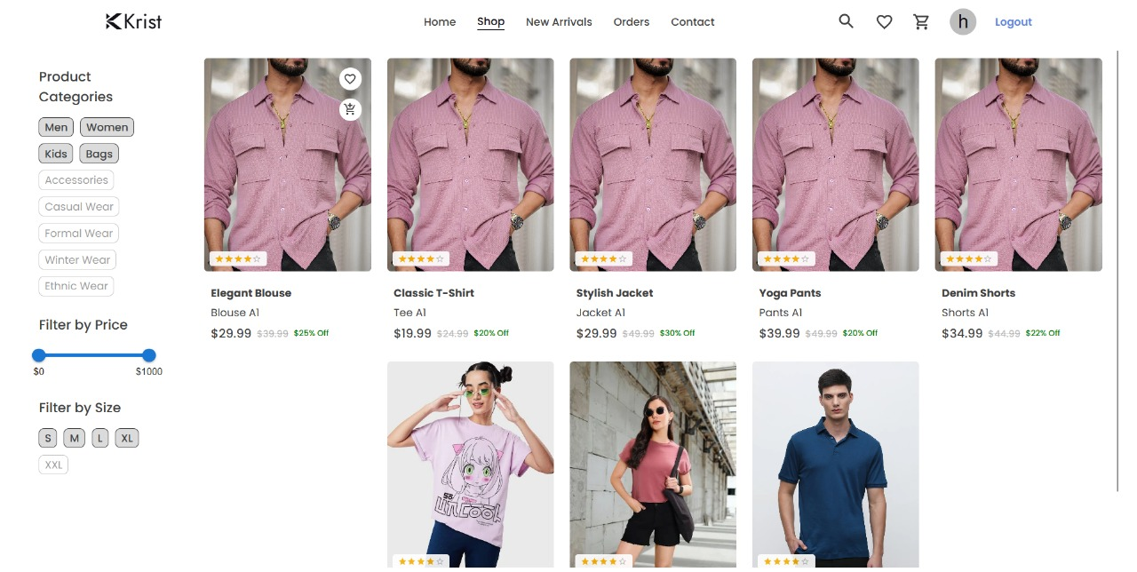

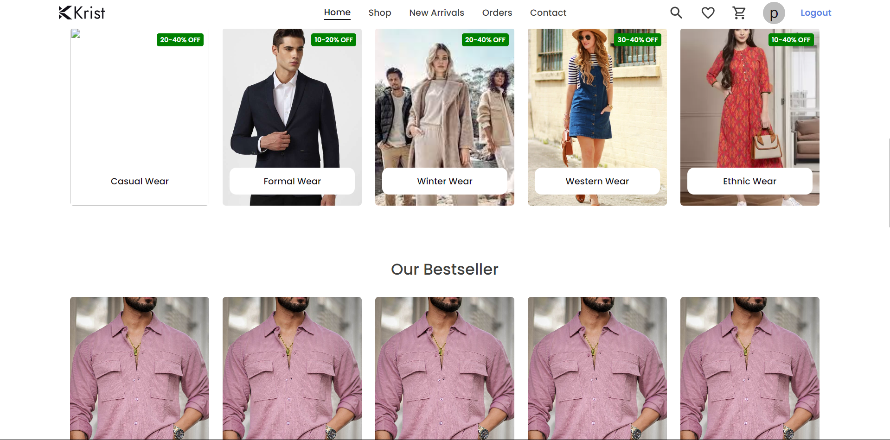



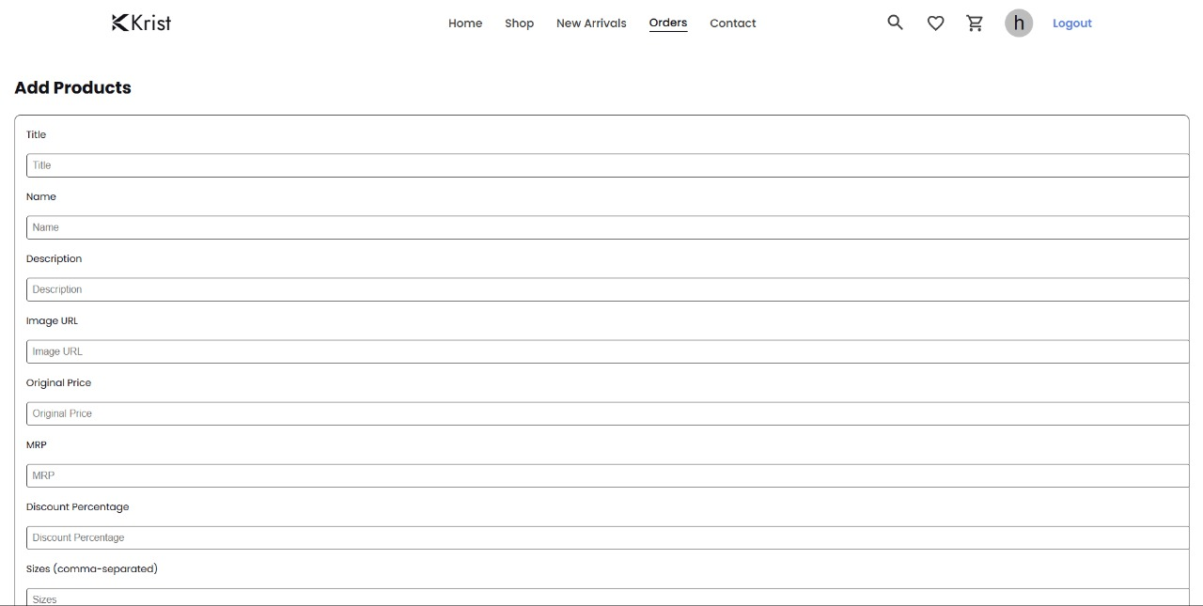

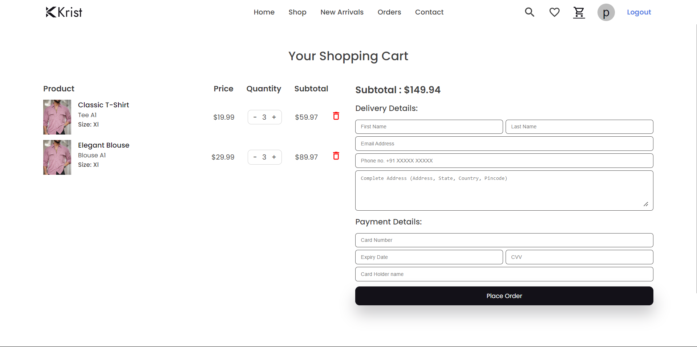



# Code-Implementation and Database Connection

The backend uses Node.js to handle API requests for document management. MongoDB is accessed using the Mongoose library, which simplifies the interaction with the database.

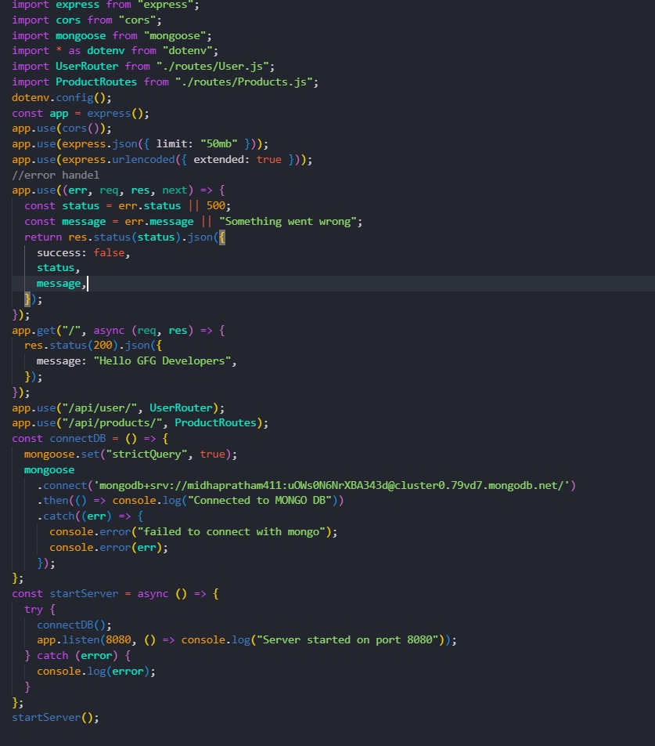

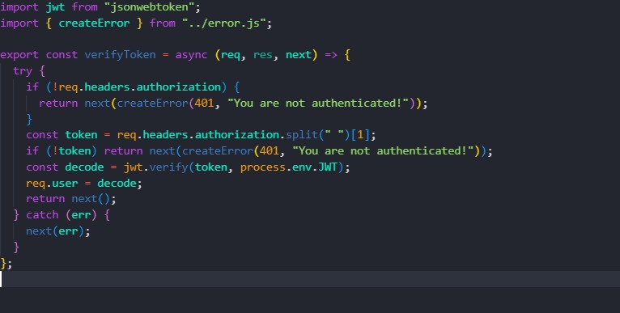



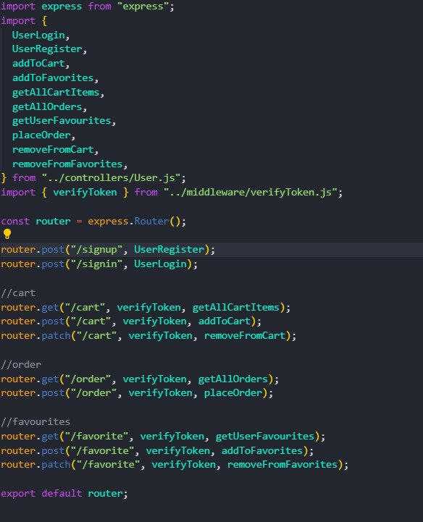z

# System Testing

Testing an e-commerce website is a comprehensive process that ensures the platform operates smoothly and securely, providing a seamless shopping experience for users. Here are some key aspects of testing for e-commerce websites:

* **Functional Testing**: This involves verifying that all features, such as product search, filters, shopping cart, and checkout processes, work as intended. It ensures that every interactive element on the site performs correctly and efficiently.
* **Usability Testing**: Usability testing assesses the user experience by evaluating the site's navigation, design, and overall ease of use\
* **Performance Testing**: This type of testing measures how well the website performs under various conditions, including high traffic volumes. It involves load testing to ensure the site remains responsive and stable during peak usage times.



# Limitations

Here are some key limitations for an e-commerce website backend project:

* **Scalability Challenges**: As the business grows, the backend must handle increased traffic and data volumes efficiently. This requires careful planning to avoid infrastructure strain and ensure performance does not degrade during peak times
* **Security Risks**: E-commerce platforms are prime targets for cyber threats such as SQL injection, cross-site scripting (XSS), and DDoS attacks. Implementing robust security measures is essential to protect sensitive customer data and maintain trust
* **Integration Complexity**: The backend must seamlessly integrate with various third-party services, such as payment gateways and shipping providers. This can be complex and requires a flexible architecture to accommodate different APIs and services
* **Technical Debt**: Existing systems may have technical debt that limits the ability to implement new features or improve performance. Addressing this debt is crucial for maintaining a competitive edge.
* **High Costs**: Developing and maintaining a robust backend can be expensive, both in terms of initial setup and ongoing management. Budget constraints can limit technological advancements and improvements

# Conclusion

In conclusion, the development of a robust e-commerce website backend is crucial for ensuring the platform's scalability, reliability, and efficiency. By adopting modern technologies such as microservices architecture, AI integration, and cloud-based solutions, the backend can support high traffic volumes and provide seamless user experiences. Advanced database management enhances data handling capabilities, while a headless commerce approach offers flexibility for frontend innovations. Together, these strategies position the e-commerce platform to adapt to evolving market demands and technological advancements, ultimately driving business growth and customer satisfaction.



# Future Scope

Future enhancements for E-commerce Website could include:

* **Microservices**: Enhance scalability and flexibility with a microservices architecture.
* **AI Integration**: Implement AI for automation and improved analytics.
* **Cloud Infrastructure**: Use cloud computing for scalable and reliable backend services.
* **Advanced Databases**: Employ cutting-edge databases for better data management.
* **Headless Commerce**: Enable flexible frontend development with a headless architecture.

# References

* **React.js:** [https://react.dev](https://react.dev/) - Official documentation for learning and implementing React.js.
* **Node.js:** [https://nodejs.org/docs/latest/api**/**](https://nodejs.org/docs/latest/api/)- Documentation and guides for setting up and using Node.js.
* **Express.js**: <https://expressjs.com/> - Documentation and guides for setting up and using Express.js.
* **MongoDB:** [https://www.mongo.db.com-](https://www.mongo.db.com-/) Documentation and guides for setting up and using MongoDB.
* **React - The Complete Guide:** Comprehensive course on building frontend applications with React.js.
* **The Complete Node.js Developer Course:** Covers building backend services using Node.js, Express, and MongoDB.